**Project Introduction**

I’ve just been hired as an eCommerce Database Analyst for Maven Fuzzy Factory, an online

retailer which has just launched their first product.

As a member of the startup team, I will work with the CEO, the Head of Marketing, and the

Website Manager to help steer the business.

I will analyze and optimize marketing channels, measure, and test website conversion,

performance, and use data to understand the impact of new product launches.

I will use SQL to:

• Access and explore the Maven Fuzzy Factory database

• Become the data expert for the company, and the go-to person for mission critical analyses

• Analyze and optimize the business’ marketing channels, website, and product portfolio

**Case Topics**

1. Traffic Analysis & Optimization
2. Website Measurement & Testing
3. Channel Analysis & Optimization
4. Product-Level Analysis
5. User-Level Analysis
6. Support CEO with performance report to the board
7. Support CEO with next funding round

**Overview of the Maven Fuzzy Factory Database**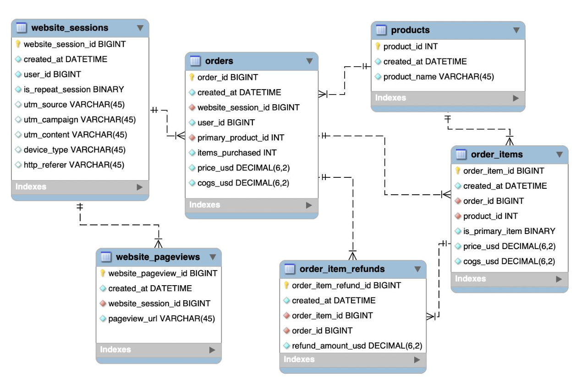

**Project Source**

<https://www.udemy.com/share/1022oW3@jG7zZcOivcJLoMmroUqCfBFE37kWBm-CgX0SoiXMxr3JPIJk2CSU1yKOtUd26HdmjQ==/>

All coding was done by myself, and the solutions are 99% different from the official project guidelines.